Childhood Success - Success Stories

United Way funds made it possible for us to provide different types of learning tools for our students.
Tyler is a third-grader who has autism. His mother passed away, and he and his siblings are currently being raised by their grandmother. Tyler often becomes angry and lashes out at other students. However, since coming to the Dream Academy and working with our staff, his patience has improved dramatically.

Tyler doesn’t care much for playing with other kids. He prefers to come inside and use the computer or the Kindle. He and I sit and discuss what makes him angry and ways to deescalate his anger. We agreed that he should ask to be dismissed from the activity and come to talk with me, or just have time to sit and reflect when he's feeling agitated. Now, Tyler often asks his after-school counselors to be excused before a problem erupts. This has helped decrease his disciplinary issues, and we are so proud of Tyler’s behavioral progression.
-
Teka Downer

Columbia County Community Connections Harlem-Grovetown Afterschool Program

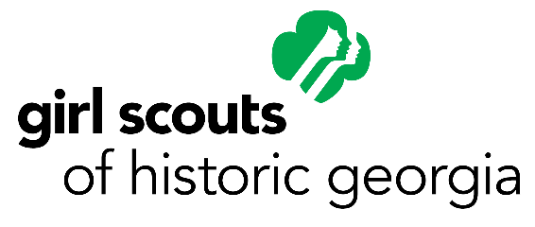

Thanks to United Way funds, Ann gained confidence and skills to help her succeed in school and beyond.

Among the many troops participating in the Girl Scout cookie program, Ann and her troop members in Augusta gained confidence and built financial skills during the program.

In addition to learning how to run and market a business, Ann and her sister Girl Scouts learned to be positive, counted money, developed proper selling techniques, and learned to track sales. Older and younger girls worked together to set goals and achieve them. Throughout the program, Ann and other Girl Scouts in her troop worked with others different from themselves while learning to navigate a multi-cultural world.

-

Debbie Smith

Girl Scouts of Historic Georgia

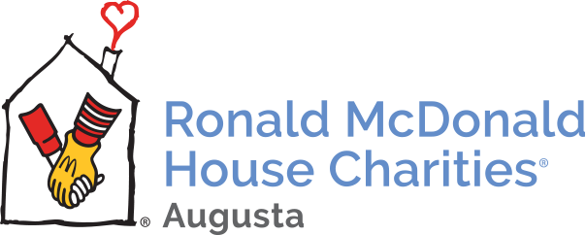

Because of United Way funds, we are able to support and comfort Haley "Cricket" and her family every time they need us.
​
At the Ronald McDonald House in Augusta, Facilities Director Nikia Bennett calls Haley Grace “Cricket” because of her playful joy, constant smile, and because “she’s always hopping around and playing."

Haley has brain tumors, epilepsy, kidney issues, and other things she has been battling throughout her young life. She had brain surgery 5 years ago.

In her mother, Rachael Peeples, words, "if it wasn’t for the Ronald McDonald House of Augusta and the staff there, I don’t know what we would have done. Our family travels now once a month to Augusta for our appointments. RMHC is our home away from home and takes the burden away from us of where to stay. Without them, we wouldn’t be able to afford to come to the best doctors around. Their staff are our family. Without them, these difficult times would be even more difficult. RMHC is our God-send and we will be forever grateful for the love, care, and compassion we feel each time we arrive at our home away from home."

-

Betts Murdison

Ronald McDonald House Charities of Augusta

Youth Success - Success Stories

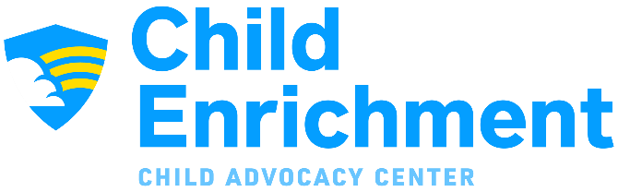

United Way funds helped pay for a therapist that helped Brittany heal from her abuse.

After enduring years of complex trauma in her home, 14-year-old Brittany was able to share her experience when she first came to Child Enrichment’s Child Advocacy Center. Once she revealed her story, she and her siblings were moved into foster homes to begin the next part of their journey.

This journey included counseling, something which Brittany was unsure of at first. Her life had taught her to distance herself and build walls between herself and others, and she often claimed she was motivated by negativity and doubt from others. Through counseling, Brittany began to realize she’d coped as best she could by making negativity work for her since it was all she had.

After over a year of counseling and participation in their SPARCS group, she has removed some of those walls and enjoys being a child instead of her siblings’ parental figure. Although she received some blame for telling the truth about her trauma, Brittany has developed healthy boundaries and surrounds herself with those who believe her. She now looks forward to graduation, college, and a future life inspiring and helping others.

-

Kari Viola-Brooke

Child Enrichment, Inc.

United Way funds help us provide specialized counseling.

Taylor graduated from high school last spring and has been trying to succeed in a welding class at Augusta Technical College in Waynesboro. He was struggling, and at first we worked on study habits, but soon realized that he was having difficulty reading.

We suggested he get an audio version of his textbooks, which seemed to help. Then, his classes were suspended due to COVID-19. To continue assisting him, we began meeting (with social distancing) to work on his social skills. he revealed a history of bullying that has made him distrustful and unwilling to ask for help. We continued to meet in person and then switched to phone calls to reinforce his ability to develop coping mechanisms for stress.

This process will continue, and Taylor admits feeling more in control of his emotions and understanding what may trigger an outburst of anger. We hope United Way funds can help him continue this self-realization journey.

-

Lynn Smith

EasterSeals East Georgia

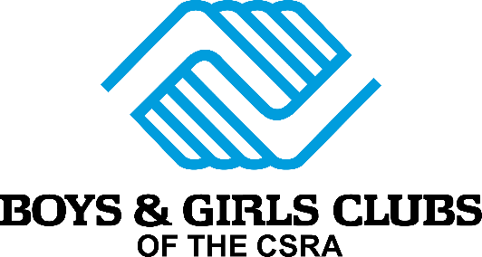

United Way funds support our programs focused on character and leadership development.

Ariana joined the Keystone Club in the summer of 2019 and attended their summer conference. Keystone is the Boys & Girls Clubs' national leadership and civic club.

While on a college exploration trip with Keystone, she was offered a $10,000 scholarship. That compelled her to become more involved with Keystone. She is now the Keystone President! In this role, she helps execute college trips for the month, runs the schedule for the Keystone Store, and leads Keystone meetings.

Ariana suffered from a skin condition in the past, but the positive energy and feedback she receives from her peers as their leader gives her comfort. This has boosted her confidence and leadership skills.

-

Adrienne Patterson

Boys & Girls Clubs of the CSRA

Workforce Development - Success Stories

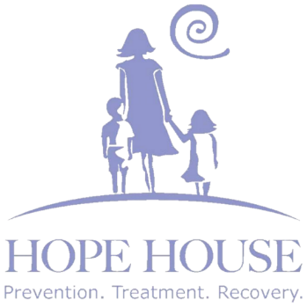

United Way funds help provide tools to cope with addiction and gain employment.
​
In Jennifer's words, "I am the mother of three children whom I love dearly. I was in desperate need of help for my addiction to alcohol because my life was very unmanageable and full of destructive behaviors. I needed to start a life that would allow me to be more productive so that I could take care of myself and my children. As I was seeking treatment, I found the Hope House website and called to set up an assessment. I went in for my assessment on July 3, 2019. From the very start, I felt that Hope House would change my life and lead me in the direction that would help me fight the battle of addiction. I felt like I could really open up to my counselor, and she assisted me with finding the perfect treatment plan that would assist in my recovery.

This was when the journey towards a better life began. Since I was in outpatient treatment, transportation back and forth to group therapy was an issue for me. Hope House of course had the solution. They assisted me with transportation. On the days that group therapy wasn't available, they had a care team that I could call or they would call me to make sure that I was doing well while in outpatient treatment.

The greatest part of this process was that I never felt judged. I was able to open up by discussing my feelings and concerns. Hope House assisted me and is still assisting me with the tools needed to help me on this road to recovery.

Hope House also has a transitional housing program that assists participants with housing and working towards sustainability. For me, this was very much needed. Receiving housing has taken the stress of worrying about providing a stable environment for me and my children while in recovery, away.

Hope House also has a program that assists with employment. All of these things have been beneficial to me while on this journey. I am employed and able to provide for my family. This is the happiest I have been in a very long time.

Experiencing the joy of being free from addiction, and having the support needed to accommodate me while on this journey has truly been a blessing. Coming to Hope House changed my life.

-

Sylvia Beam

Hope House

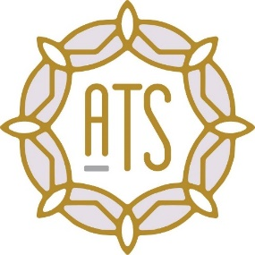

United Way funds help us provide individuals like Trenton stable, permanent employment.
​
Trenton came to Augusta Training Shop several years back with an eager excitement to begin working. Trenton had never created art with his hands, but this was about to change. We fell in love with Trenton the minute we met him with this positive personality, willingness to learn, and uplifting spirit.

Trenton was not 100% sure of himself, never making handmade items. He was a bit shy to accept affirmations of his work, but soon began feeling comfortable. His coworkers surrounded him with love and acceptance immediately. After years of hard work making snowflakes, Trenton was chosen by Walt Disney World to tell his story about his work at Augusta Training Shop.

Walt Disney World sent a film crew to our shop to learn about our snowflakes, and our employees that make them. Trenton was thrilled to be chosen and did a great job on his interview. After seeing his video and the interactions online, it has made Trenton feel very special. He thinks he is now a movie star and loves to hear from people around the country who have heard his story!

-

Audrey Murrell

Augusta Training Shop, Inc.

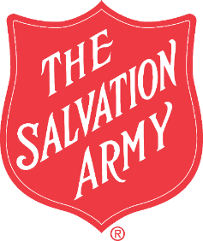

United Way funds allow our Job Skills Training Program to invest in highly trained and professional facilitators.
​
The following success stories share graduate reflections on knowledge and tools gained from the Winter 2020 Job Skills Training Program session.
​
“I am most proud of being able to see this program through, despite so many challenges in the last weeks. My confidence has been the biggest change in my life since starting this program. I now know what I am capable of and understand my priorities and goals in a different way than before.” - single mom of one, age 22 and in recovery after 9 years of drug abuse
​
“This program has made me such a better me in ways I thought I was already good at. Not only have I made progress, I have succeeded with my goals. I got a job as a Pharmacy Technician. I had a major obstacle in the middle and I overcame it. I am most proud of completing the program to the end.” - single mom of three, age 24

“The biggest change in my life is that I now face each day with a positive, open mind. I could relate to each and every aspect of what was offered in this program. The instructional classroom time was the most effective, with thanks to the coordinator (Amanda Crooks). It has helped me positively shape my days. All of my plans, goals, and achievements will be different because I now know myself and I’m confident in my own strengths. I have made significant progress on all of my short-term goals. The biggest change for me is in my confidence. I will now approach each task of every day with confidence. - single mom of three, age 31

-

Kristin Cordaro

The Salvation Army, Augusta Area Command

Access to Resources - Success Stories

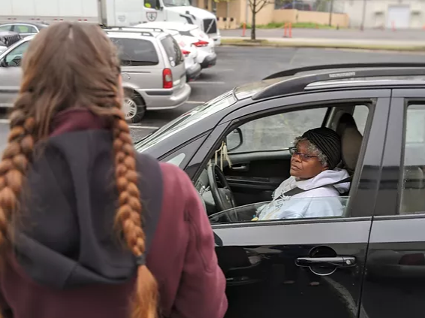
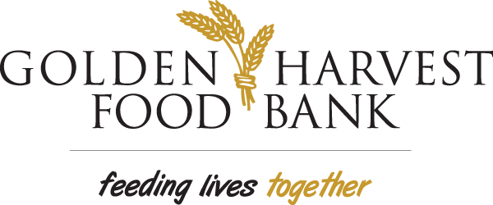

United Way funds help us provide emergency meals to hungry individuals and families.

Jewell, a military veteran with a spinal cord injury, wouldn’t normally need help with food. “This is my first time getting help because usually my daughter can send me food,” she says. But that has changed.

Jewell’s daughter and grandson lives in Philadelphia, and Jewell is driving to Pennsylvania to pick up her grandson and bring him back home to stay with her so that her daughter can keep working while he is out of school.

“Now it will be me and my grandson. It’s going to make it a lot harder,” she says. “Whatever little money I do get through social security goes to upkeep of the house and to food.”

-

Amy Breitmann

Golden Harvest Food Bank

United Way funds provide financial assistance for safe housing and education training. Funding helped to move this family forward, eliminating barriers to help them succeed.

Ms. Bee entered our shelter due to a domestic violence situation. Because of this situation, she was having to live in poor housing conditions which led to DFAC removing her children from the home.

When she entered, she was working part time for her sister’s cleaning business and was receiving disability benefits. Our staff provided case management and spoke with Ms. Bee about receiving educational training. Through a partnership with Training for Life, Ms. Bee registered for a CNA class with help from our staff.

We provided Ms. Bee with clothing, personal items, and transportation to visit her children. She also successfully completed CPR/ First Aid and CNA classes. Additionally, our staff assisted her with locating safe housing prior to leaving our shelter. Ms. Bee was able to move into a new home with her children and begin putting her life back together.

-

Aimee Hall

SafeHomes Domestic Violence Intervention

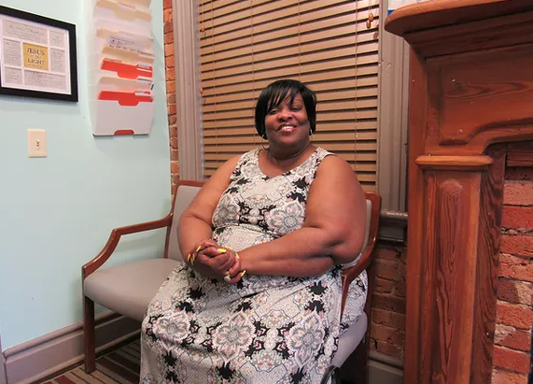

United Way funds help us provide vital health care services.

Beverly told us “I've seen so much improvement since coming to Christ Community. I have severe asthma. Dr. Jeremy Wilson informed me about an effective treatment called NUCALA. I haven’t been at the hospital in probably over about two years. Before that, I was in and out of the hospital a lot. The staff at Christ Community are incredibly welcoming. Every time you leave, they pray with you and pray for you. The doctors take time to answer your questions, explain everything to you, your situation, what you need to do and what you shouldn't do. I feel so much healthier now.

-

Ron Skenes

Christ Community Health

