Childhood Success - Success Stories

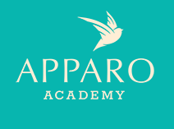

United Way funding helped us hire another teacher so that we could accept an additional child into our program and provide him with the nursing and therapy care that he needs each day.
Braylon's mother was very concerned about her son's development and her inability to work because she couldn't find placement for him in a daycare with his conditions. She told us her son was diagnosed with HIE (loss of oxygen to the brain) at birth. As a result, he wasn't walking, talking, eating, or sitting alone. This meant that he would require a lot of individualized care while at school.

Unfortunately, we were unable to enroll him in our program at the time because of his extensive need and our lack of staffing to cover another child.

Then we received the United Way funding and were able to hire two more teachers. One of those teachers would care for 4-year-olds, which allowed Braylon to enroll in our program. It was an exciting day for everyone involved!

Now, Braylon is making progress each day and is starting to become more alert at home as a result of his care and interactions at Apparo. We are so grateful for the funding that allowed us to hire two additional teachers and accept children like Braylon into our program.

Jennifer Jones
Apparo Academy
Early Education and Intervention Program

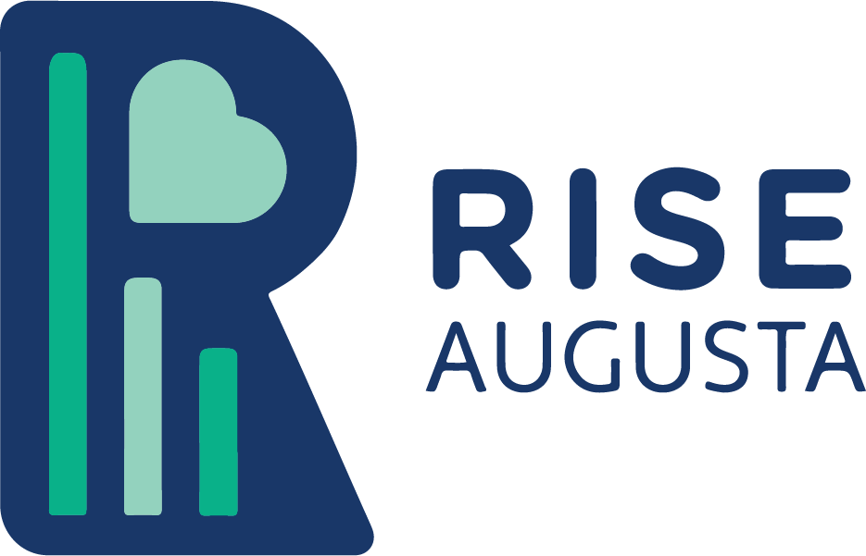

A small amount of United Way funding provides incentives such as candy, erasers, and pencils. These treats can often be the difference between a student who wants to do more and a student who is unmotivated to advance. Alecia’s response to the positive reinforcement shows the effectiveness of this model.

Lamar Milledge Elementary School invested in a program this year called Accelerated Reader. Its purpose is to encourage kids to read more by offering tests on various books, allowing kids to track their progress, and teachers and staff to reward them for passing these tests.

A couple of kids on the caseload have taken the format and prospered within. Additionally, 1/3 of the students attended the "AR Dance," which required a certain amount of points with a pass rate of over 80%. One student in particular named Alecia is currently the top AR reader in the 3rd grade. In our room, we reward reading success with treats such as candy, erasers, and pencils, and Accelerated Reader's implementation created a more efficient tracking model of their reading scores.

For instance, just looking at Alecia’s numbers alone, her reading level has improved from early 2nd grade at the beginning of the year to solidly on grade level currently. She is even reading chapter books.

Through positive reinforcement and her ability to tangibly track her performance, Alecia has proliferated, and that postulate holds nearly universal throughout our caseload.

Laurie Cook
RISE Augusta
Helping Hands Program

Without funding from United Way, we could not have our afterschool program. Funding helps keep our afterschool program going so that we can partner with incredible organizations such as Columbia Fire and Rescue.

Because of a valued partnership with Columbia County Fire and Rescue, enough money was raised to take each of our afterschool students shopping right before Christmas.

Our students were so excited to go "shopping with a fireman!" Many of them shared the same sentiment of wanting to get items for a younger sibling and not just themselves.

Teka D Jenkins
Columbia County Community Connections
Harlem-Grovetown Afterschool Program

Youth Success - Success Stories

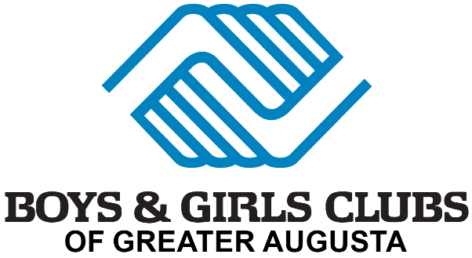

United Way funding allows children like Jasmine to grow, free from judgment through understanding staff and new opportunities. She can now take her newfound confidence and apply it to any part of her life. She is no longer afraid to try new things or be herself, and the Club has been instrumental in that change.

Jasmine grew up in the Augusta area with her brother and mother. Her brother was the more the loud, energetic, boisterous type. Jasmine usually erred on the reserved side. Jasmine grew up estranged from her father, struggling to establish a connection with him and his side of the family.

Though she did well in school, Jasmine didn’t join any extracurricular clubs or activities. After school, she would come straight home. Other than her family and personal friends, Jasmine didn’t spend much time or energy trying new things.

When Jasmine first joined the Club, she had no intentions of participating. Because of personal insecurities. She felt more comfortable not engaging with various activities around the Club. She used this as her shield. If she didn’t try, then she wouldn’t have to worry about potentially being embarrassed or left out. She would feign disinterest and tell herself that she didn’t want to join anyway.

However, after seeing how her brother would come to the Club day after day, putting himself out there and being accepted, she began to consider taking a leap of faith. Slowly but surely, Jasmine tested the waters by opening up more to staff and other members. She joined in on group games or projects that she would have earlier passed up. She now embraces a more artistic side of herself by participating in dance classes at the Club and discovering her interest in drawing.

Nowadays, she can’t envision a life apart from the Boys & Girls Club. She’s been a member for many years and it’s a place that she can consider being instrumental to her growth.

Jasmine is an example of what the Club is meant to do when it works. We help turn children who need us the most into productive, caring, responsible citizens. She’s now indistinguishable from the person she used to be. She loves to be involved and try new things. She’s now the one to get her friends to try activities they don’t believe they will like!

Adrienne Patterson

Boys & Girls Clubs of Greater Augusta
Afterschool and Summer Programs for Teens (ages 12-19)

United Way funding for autism services provided resources for extended coaching to help a young woman and her family achieve effective transportation planning for their household.

Katie is a shy, very reserved high school student in Columbia County Georgia. She is on the autism spectrum. The nature of her home location requires being able to use automobiles for transit. She has a devoted mother, who works in the medical field and often has extended work hours.

Katie and her counselor from EasterSeals began planning for her to study for her permit and license process soon after she began her life coaching lessons.

Individuals on the spectrum often resist trying to drive for many reasons including anxiety, trust, and attention issues. She was not immediately sold on her need to develop this skill and expressed the belief that her mother would always be able to help with transportation. Her mother was actually very eager for her daughter to drive to ease some of the stress of her daily schedule. We worked through a plan that included reviewing the rules of the road and discussing scenarios in which driving would be an asset.

Over time, Katie became comfortable with the idea and registered for classes, but unfortunately, an illness developed that slowed her progress. Her counselor did not stop encouraging a return to the driving education process. This encouragement continued for several months. When COVID hit, this gave the family a bit more time to practice and Katie obtained her license.

She now drives herself to and from school, which cuts down on ride time and allows her more time to study. The ultimate goal for her driving was to attend Augusta State University and provide her own transportation. She is now on her way to achieving that goal.

Lynn Smith

EasterSeals East Georgia
Autism Support Services

United Way funding made possible learning skills and giving back to the community in ways that lead to a stronger academic journey and regular school attendance for our youth.

This summer, Troop 20025 made and donated pillowcases to the Ronald McDonald House in Augusta. Abby and Julianne made and donated 100 of the pillowcases!

Debbie Smith
Girl Scouts of Historic Georgia, Inc.
Traditional Troop for Youth Success

Workforce Development - Success Stories

United Way funding helps our organization afford job skills and job readiness workshops, which allows our clients to become self-sufficient.
​
Our client KJ entered the shelter last year due to domestic violence. She and her two children had been living from place to place because she lost their home due to being out of being from the COVID-19 pandemic.

Shortly after, she entered the shelter and began receiving services that would help with workforce development. KJ turned her focus on securing employment and housing in order to provide a safe place for her and her children to live as she gained autonomy. During KJ’s stay in our program, she was able to obtain a job at a local hotel and began work immediately.

Staff assisted KJ in locating an affordable apartment and provided financial assistance with utilities. During Ms. KJ’s departure, staff was able to obtain a wish list of essential items needed to start a new home and was afforded the items along with groceries. During her stay at the shelter, she was informed of trainings she could take to help advance her skill set. She was able to complete an application for a Pharmacy Tech class and will receive a certificate when she completes the 16-week training.

Aimee Hall
SafeHomes Inc.
24 Hour Crisis Intervention

United Way funds help us provide support and training to veterans through our Employment Program.

Bridging gaps and ensuring access to resources to improve the lives of veterans in our community is the heart of our Transition & Reintegration Advocacy Program.

With Thomas Gaskins, 68-year old Veteran of the Vietnam War, our Advocates have been able to do just that. After completing a program at the VA in 2016, Thomas Gaskins was referred to ForcesUnited for housing assistance. At the time we were able to successfully find him a place to live along with support to become independent within 6 months.

This past February he contacted ForcesUnited again inquiring about employment assistance. Thomas was looking for something part-time to supplement his SSI. He did not have a resume and wanted assistance in finding and applying for jobs, explaining that he was not computer literate at all. He didn’t have a computer and did not understand how to get online and apply through websites, so he wanted to sit down face to face with an employment advocate for assistance.

The next week, Thomas came into the office. He worked with ForcesUnited Director of Employment, Kimberly Norville, to create a resume and identify job opportunities that would match his abilities and wishes. Taking his time, Thomas verbally detailed his work history as Kimberly typed a resume outline for him. Thomas then expressed interest in security positions, but it was clear that he would not be able to apply online on his own.

To make sure his application got submitted, Kimberly walked him through the steps on the Sizemore Security website. Thomas was able to verbally describe answers to the questions, and Kimberly systematically applied for positions as a security guard, crossing guard, and parking lot attendant. Within 2 weeks, Thomas was pleased to have been offered a position as a parking lot security attendant. Thomas loves working his morning shift of 4:30-8:30 a.m. and excitedly puts on his uniform each morning. He says, “Life is good; I’m a happy man. ForcesUnited straightened me up.” Thomas went from protecting our nation in the military to protecting citizens right here in Augusta, thanks to ForcesUnited bridging several gaps.

Kimberly Norville
ForcesUnited Inc.
Transition & Reintegration Advocacy Program (T&R)

Funding from United Way allows the Job Skills Training Program to invest in highly trained and professional facilitators which are able to connect with our participants and pour into them the knowledge and information necessary to be successful in their career search.
​
A. Smith found out about our Job Skills Training Program through the Augusta Housing Authority. A. Smith's life took a turn when she met the father of her children, who at the time was already heavily using drugs. Throughout their time of dating, they would have 3 beautiful daughters.

Shortly after, she would succumb to a life of using drugs as well. She would be further impacted when she lost custody of her children. At this time, she was also pregnant with the third daughter. Through the Augusta Housing Authority, A. Smith was introduced to support groups to assist in recovery from her then, current state of drug use.

She started taking the parenting, relationship, and crisis in pregnancy classes and would be on her way to being drug free. A. Smith has been drug free since 2017 and moved to the next phase of her life including calling to interview for the Job Skills Training Program. Since having joined the job skills training program, she has worked hard to develop the skills needed to accomplish her goals set to better her life.

On the second week of job skills, her attorney called to follow up on her progress because they would shortly be returning to court to speak on her behalf about regaining custody of her children. The next day, while meeting with A. Smith, she let me know that through being in the job skills program and the progress review I provided her attorney, the courts made the decision to release her children back to her custody. A. Smith has successfully completed the Job Skills Training Program and soon after, the courts made the decision to release her children back to her custody. She has a full-time job and says she is developing and repairing her relationship with her 3 beautiful daughters.

-

Franshon Hollis
The Salvation Army, Augusta Area Command
Job Skills Training

Access to Resources - Success Stories

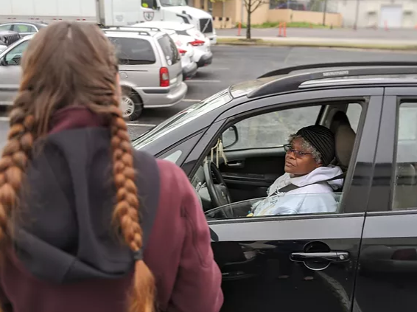
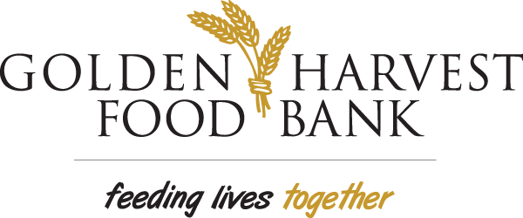

United Way funds help us provide emergency meals to hungry individuals and families.

Golden Harvest held a huge food distribution in the parking lot at James Brown Arena. We had tons of volunteer help from many community partners, including GAP Ministries, Mercy Ministries, Inc., Lutheran Church of the Resurrection - Augusta, GA, Project Life, Light of The World Outreach Ministries, and DCCM Food Pantry. Funding from the United Way helped Golden Harvest fund this distribution and others like it.
​
It was our biggest distribution in Golden Harvest's history! With the help of about 60 volunteers from 8 Richmond County Community Partners, staff from both our Augusta and Aiken offices, two 53' foot trucks, 3 refrigerated vans and the James Brown Arena, we distributed about 56,000 pounds of food to more than 730 families that Saturday. Fortina is a senior citizen who came through the distribution at James Brown Arena. She was a first grade teacher, then she worked for the healthcare system for 20 years as a nurse. She's came to the distribution because she's got some food but she wants to make sure she doesn't run out. She doesn't always have the money for food when she runs out. Also, she's a senior, so she's always concerned about going out in public during the pandemic. "I’m not out of food yet, but when I do run out, I don’t always have the money to buy more."

Christina Alexander
Golden Harvest Food Bank
Emergency Meals Program

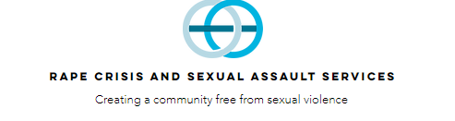

The funding we receive from United Way allows us to provide trauma-focused therapy and support that enables victims of sexual assault to work through self-blame and obstacles that allow them to reconnect and form strong relationships with family and friends without fear of blame and judgment.

The United Way helps us to restore their self-worth and desire to live again.

Our client was almost estranged from her family and isolated herself due to the fear of being judged. This was her first time seeking counseling. Only prompted by family to obtain help. She was shy, fearful, and apprehensive. She needed encouragement to voice why she sought help. She reported, passively avoiding relationships with her family due to her unfounded belief that they would judge her based on the trauma she experienced.

Upon engaging in the therapeutic relationship, delving into her story, and challenging her beliefs, her confidence grew. Her internal operating system shifted. She became open to explore new relationships that were built with healthy boundaries. She began using her voice again, by speaking out in public situations. She leaped and opened up to her family about her trauma. She has stated, "I'm ready to live."

Tiffany Luke
Rape Crisis and Sexual Assault Services
Advocacy and Prevention Education Program

Thanks, in part, to United Way's support, Chandra got the life-saving medications and basic medical care she needed.

Like many other Christ Community patients, Chandra didn’t have health insurance. In December of 2017, Chandra had a brain aneurysm, and then three months later she had two mini-strokes. “I’m on a lot of medicine,” explained Chandra. “To tell you the truth, I don’t know where I would be without Christ Community because, they’ve been working with me and I got approved for my Medicare. I’m glad people donate to help others that can’t get insurance,” said Chandra.

Ron Skenes
Christ Community Health Services Augusta
Health Services

